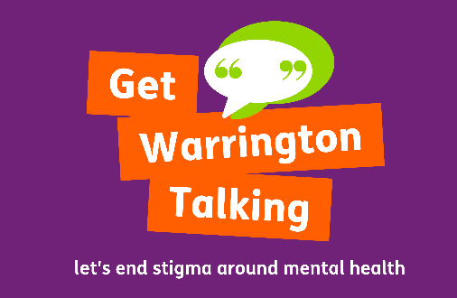

VOLUNTEER APPLICATION FORM

Get Warrington Talking’ endeavours to create a culture of knowledge, understanding and support around mental health, mental illness and suicide prevention. We do this through informal conversations, listening spaces, specific activities and awareness events in our local communities.

We are seeking volunteers who can use their experience to help us to achieve this aim.

As an organisation we are keen to support volunteers, providing training and opportunities to develop knowledge and skills. In turn, we ask potential volunteers to provide some commitment to this role and would appreciate you being honest and realistic about how much time you are willing to give before you apply

Please can you complete this short questionnaire before we proceed with your application, the contents will be treated as confidential.

Personal Details:

Surname: Click or tap here to enter text. | Forename(s): Click or tap here to enter text.
Address: Click or tap here to enter text.

Click or tap here to enter text.

Click or tap here to enter text. | Postcode: Click or tap here to enter text.
Mobile Number: Click or tap here to enter text. | Landline Number: Click or tap here to enter text.
Email address: Click or tap here to enter text.

Please can you share with us why you would like to volunteer for GWT

Click or tap here to enter text.

How will your own experience support you in this role?

Click or tap here to enter text.

How many hours are you looking to volunteer?

Click or tap here to enter text.

Thank you for your time and for considering volunteering with us.

