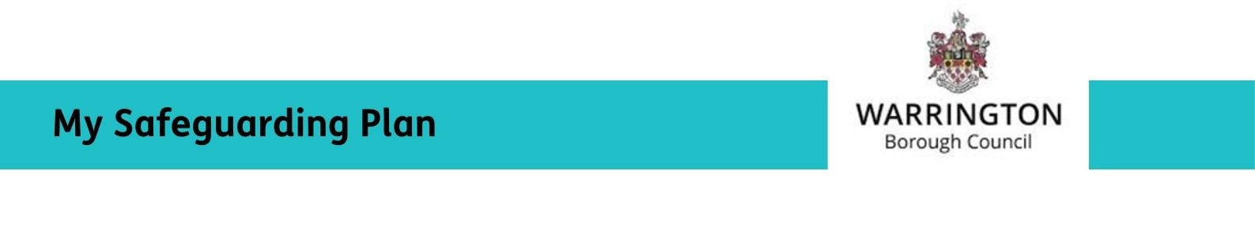
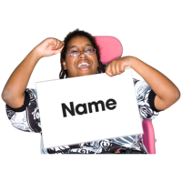
My name is:

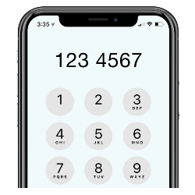
My phone number is:


Who I want to support me:

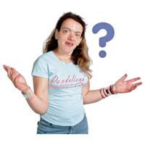

What I know about the safeguarding concern:


My worries:


What is important to me:

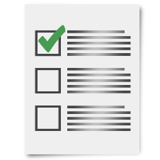
These are some things I want to happen

I want the abuse to stop.

I want to feel safer.

I want to be listened to and be treated fairly.

I want other people to be protected from harm.

I want support for the person causing harm.

I want my property or money back.

I want to have more control over my life.

I want to know how to get more support or help.

I want the person or the organisation who has caused harm to take responsibility for what they have done.


Anything else I want to happen:



